Thank you for purchasing the Diablo watch water resistance tester. We have designed the Diablo for ease of use and durability at an economical price.

We HIGHLY recommend that you view the video of the features and operation of the Diablo at our website www.LititzPP.com. Use of the Diablo does not guarantee water resistance. The operator must understand the principles of testing and the limitations of the technology.

The Diablo vacuum leak detector functions by drawing a vacuum over the watch. The operator watches for bubbles to exit the watch which shows the location of the leak. The Diablo is powered by a 9V battery or 100- 240 VAC UL/CE listed power supply.

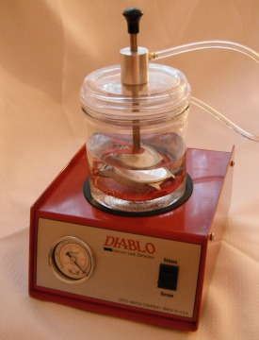 |  | - All Corrosion resistant aluminum and stainless construction  - Durable components. Expected pump life 115 years at 3 tests per day.  - 100-240 VAC operation.  - Battery operation for countertop use. Battery life estimated at 60 tests  - Five Common international adaptors included  - FAST and easy to use  - Made in USA

- Select the proper AC adaptor plug from the selection provided
- Install it in the AC adaptor

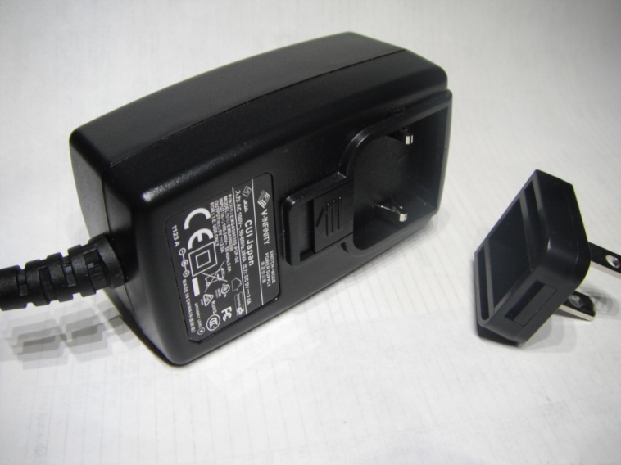

- Install the 9V battery and battery tray into the back of the Diablo. The open side of the tray faces up. For best operation, please note battery polarity when replacing battery..

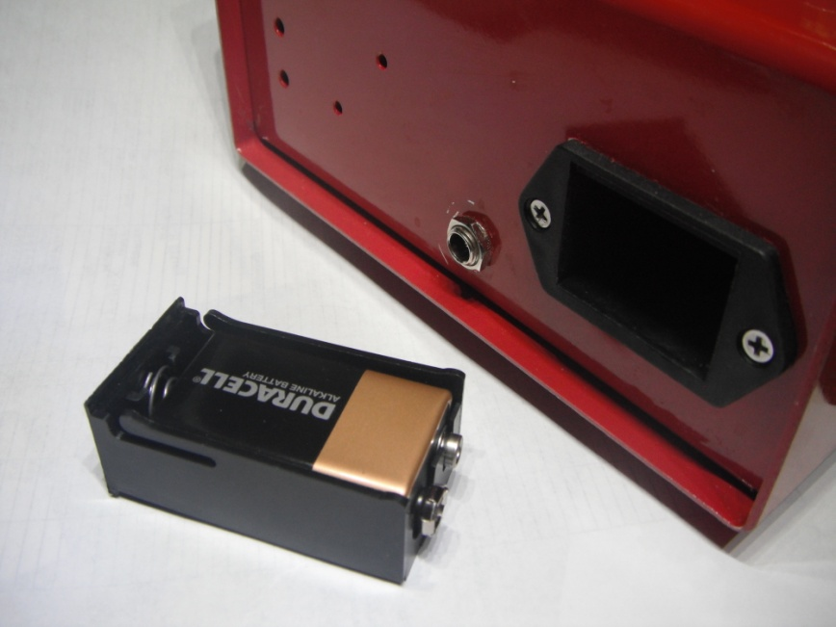

- Plug the AC adaptor into a 100-240 volt receptacle.
- Plug the adaptor into the rear of the Diablo.

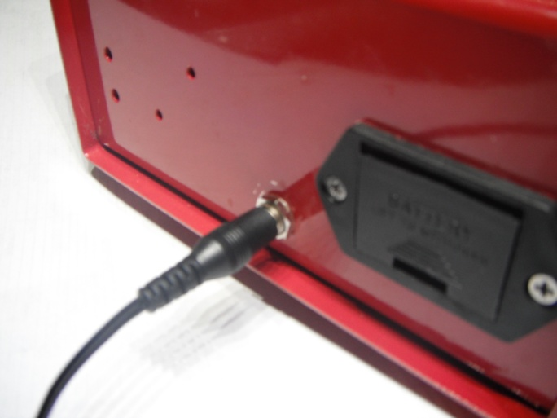

- Fill the jar about half full with clean water. Using distilled water will reduce mineral buildup

- Lay the watch, with a minimum of one spring bar installed, on the red tray/watch holder. The tab on the inside of the tray is designed to keep the watch elevated above the tray so there is an unobstructed view of all sides of the watch.

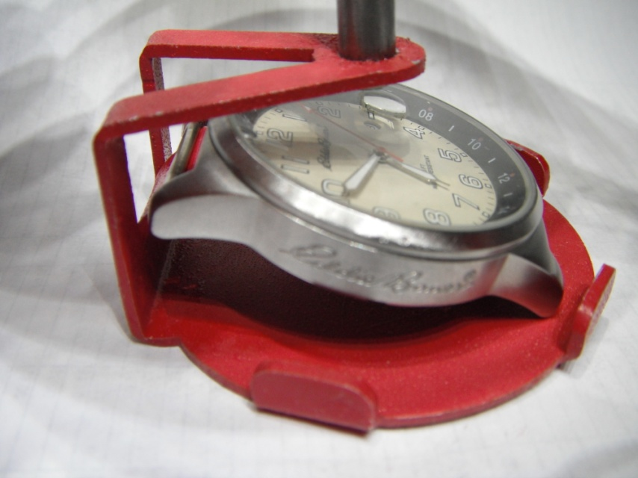

- Place the watch holder assembly inside the jar and lower the watch into the water by lowering the lifting knob.
- Apply slight manual downward force to the top and activate the vacuum by pressing the front panel switch down.
- Once vacuum starts to build, manual force on the top can be released as the vacuum will maintain the seal.
- Visually check for bubbles coming out from the watch. Bubbles indicate that there is a leak.
- Lift the watch out of the water by pulling on the lifting knob while holding down on the top of the jar.
- Release the pressure by lifting the switch on the front panel.
- Remove the watch from the jar and the test is complete.

Lifting Knob

Jar

Watch Holder

Vacuum Switch

Vacuum Gage

Lititz Watch Co
119A North Broad Street
Lititz PA 17543 USA
www.LititzWatch.com
717 627-1227

