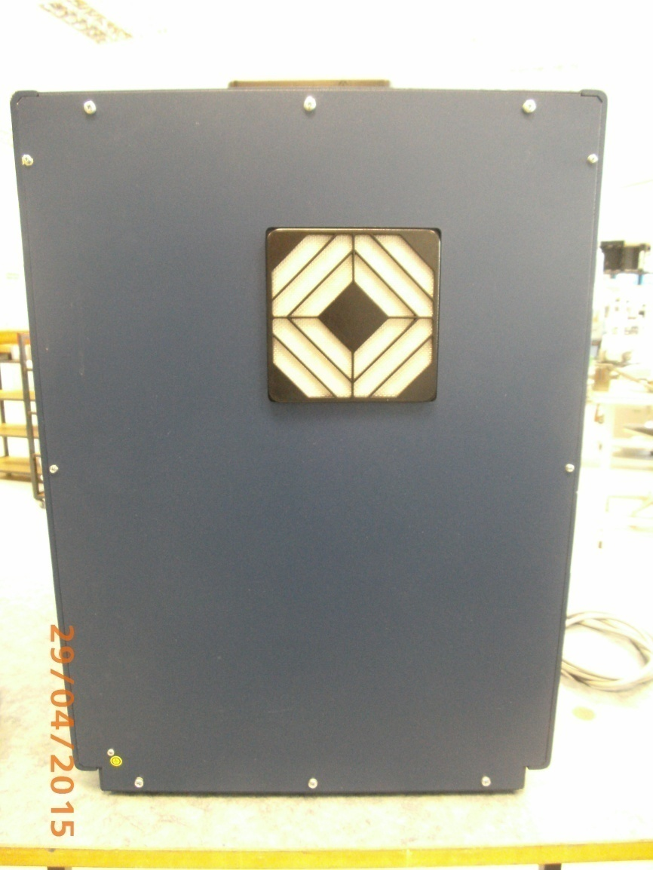

Disconnect power plug before opening.

Remove the 4x screws M3

Remove the 6x screws M4

Pull the lid carefully backwards and place it on the left side of the device.

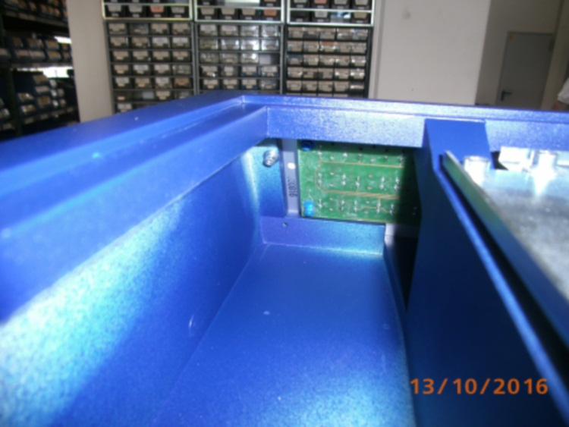

Remove the socket head screw M3.

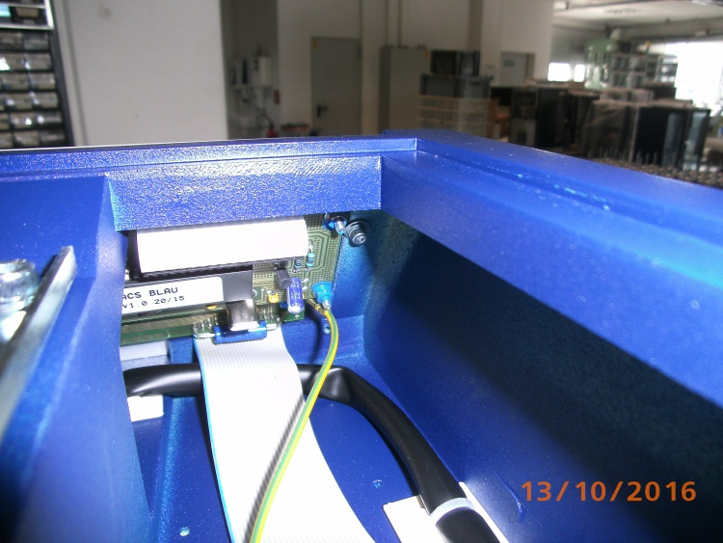

Remove the socket head screw M3.

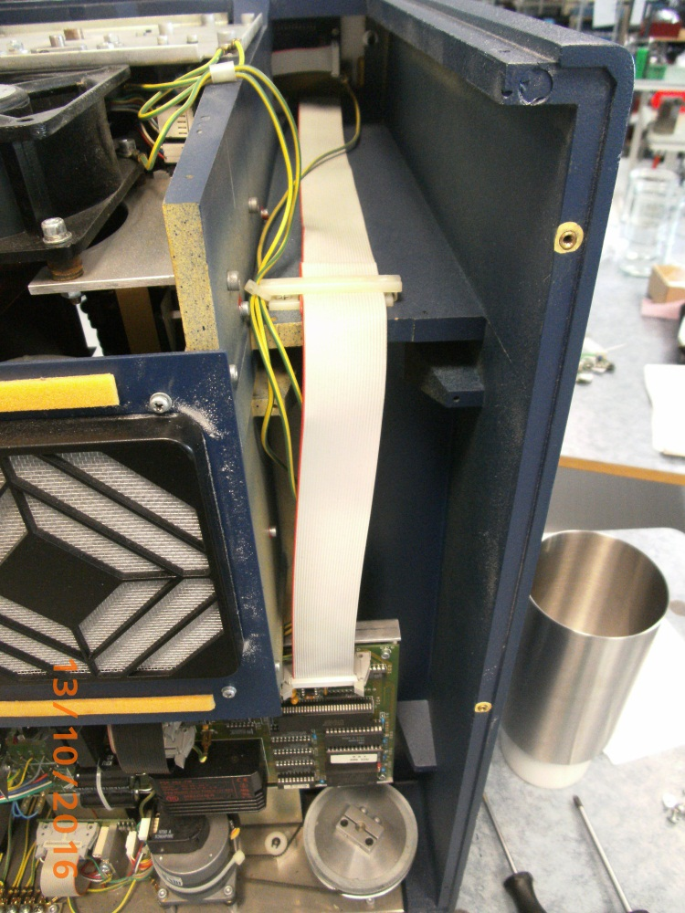

Disconnect the ribbon cable. (Pay attention! there are different holders)

Disconnect the ribbon cable here also.

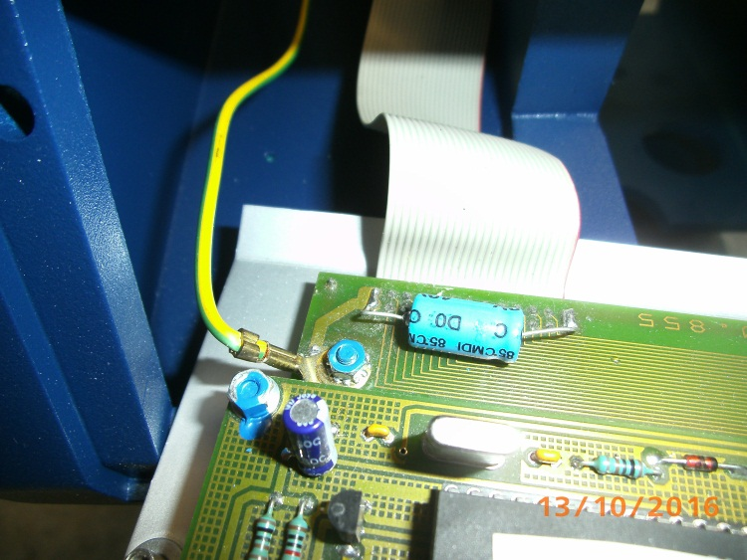

Fold the front panel slightly forward.

Remove the nut M3 and remove the ground cable..

Then remove carefully the front panel.

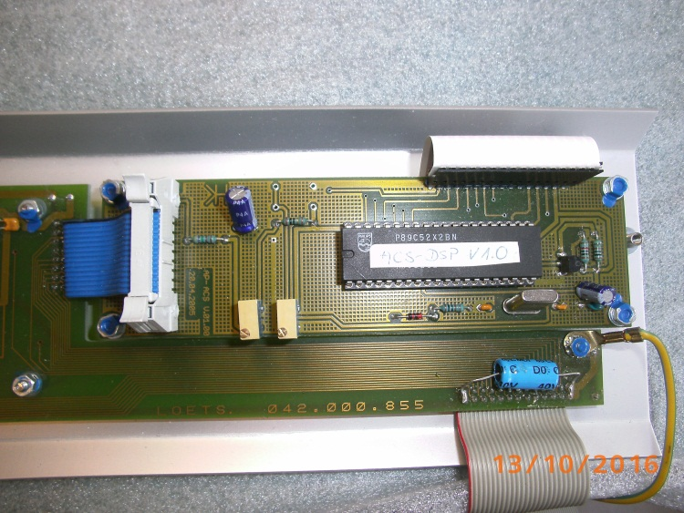

Disconnect the ribbon cable.

Remove 4 x nut M3.

Remove carefully the power board and disconnect the ribbon cable.

Then remove the remaining nuts and discs.

Remove the faulty and insert the new display.

Reassemble in reverse order.